Capsulefy: User manual

When not logged in, an user is only able to list capsules that have been released, search a specific capsule using a keyword contained in the title, release date or description.

By clicking on “Search capsules” a list with all the capsules available will appear, as well as a search bar

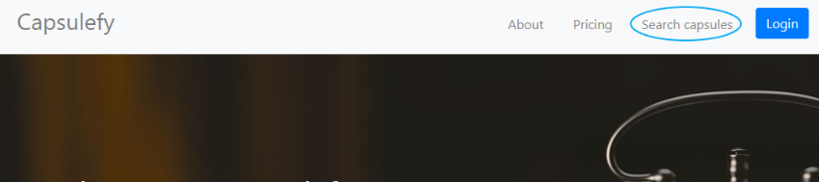

By clicking on “Display capsule” the contents of the capsule will be fully displayed.

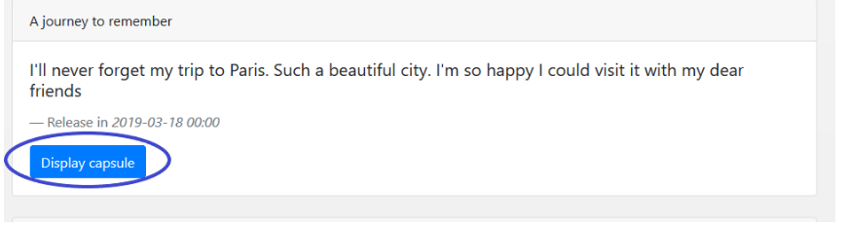

When logged in, each user can create free capsules, with the restriction of only being able to store inside them up to 20mb in total per user.

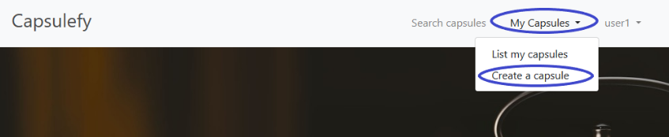

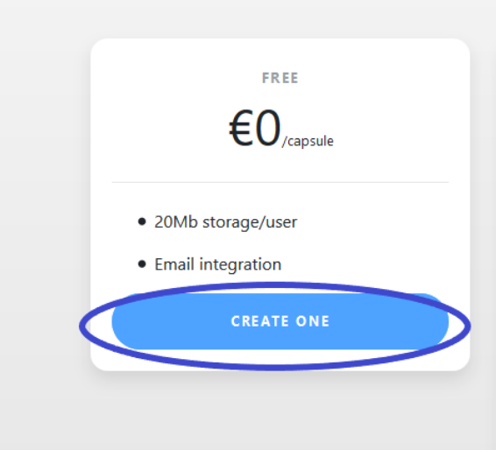

In order to create the capsule, it is necessary to introduce at least a title, a description and a publication date following the pattern yyy-mm-dd, being yyyy the year, mm the month and dd the day. In the email fields, multiple emails can be entered, separated by “,”, and an email will be sent to them when the capsule is released. Finally, files can be uploaded, as long as they don’t exceed the free user limit. Capsules published by the user logged in can be listed by clicking “my capsules”. These capsules can be edited as long as they have not been released and they can be deleted anytime. To edit or delete a capsule, please go to “List my capsules”, display the capsule to modify or delete and click the “Edit” or “Delete” button.

When clicking on “Create a capsule”, users can also choose to create a premium capsule instead of a free one by paying 11.99€, although for this prototype payment is not implemented, so creating a modular capsule is as simple as following the previous process. However, it has some additional fields. Firstly, a premium capsule can be made private. By selecting this checkbox, the capsule with not be included in our listings and user can only access to it if they know its url. There is also the option of setting a deadman switch. By clicking the checkbox of “Create deadman switch”, a new option will appear in the form, with allows to customize the time after which the capsule will be automatically published if the user has not refreshed it. At the moment, our timers are updated once a day.

Lastly, these premium capsules are divided into modules. If the user wishes to, he can click on “add module” to create a new module inside the capsule, with a different description, release date and files. These modules can be deleted and modified.

Lastly, to refresh the timer of a capsule, it is necessary to display it and press the “refresh” button.

Pilot users will receive credentials so they can log in to a specific account. Evaluators will have the dummy users credentials inside a readme file located in the deliverable.